FeelingEUROPE (*) 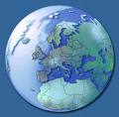
Desk for European values and affairs 18 June, 2009
___________________________________________________________________________________________________________________ ________ ___________________________________ _______________

23 June CEPS is holding the event Quo vadis Financial Markets? The state of play after the European Council.
In order to contribute to further restoration of the financial (and economic) system, some thoughts and questionings
are positioned.

WHO STARTS NEXT?

Money and financial markets matter. Prosperity of societies depends on it. Previously classic banking systems
were known for a long time as established reputation. There was reason for existence, trust, good governance and
clarity in objectives, i.e. practising business and working on continuity.
Positioned within the economic system, the sector provided services on financial products and was of eminent importance as intermediair and catalyst. Financial institutions operated with the help of valid internal organization, ordered administration and (management-)integrity.

Caused by the markets and policies, now solvency matter, there is low volume and turnover in money, stocks and
interbank-lending and there is also no acceleration, by which credit flows does increase.
What bottlenecks should be solved yet? Where are the lenders, borrowers and financial intermediairs in order to
crank up the markets and when will they actually start?

It appeared that more losses should be expected (due to future failures and Eastern Europe debts), but that no
toxic assets are left. Also there is talk of low level of inflation rate. If quantity of money in the system is relatively
adequate and housing prices are balanced, the running speed can increase and broad money growth start again.

Looking to the core, roles for financial markets looks after needs of integrated financial solutions for finance, investment and hedging to improve liquidity. For this purpose, leading is function and usage of different financial products for customers and banks on the money- , finance- and foreign exchange market and the market of derivates.
Required is also pricing of the various products.

Regulations and supervision has been and is on top of agendas. This contributed already to recovery of trust.
A better recognizing of the risks, coupled with the different activities of financial institutions on the financial markets, is reached. A thought is creating one spot where movements of money-flows in most important currencies can be centralized and monitored in order to keep control.

What to do to restore further?
Keep stimulating the demand on one hand and on the other go for conservative finance of sustainable renewals in fields as energy, carbon, commodities and technology.
Convertible bonds could come in front. Swaps, futures, options are allowed as long as they are used to control risk and not to exploit risk.

What else?
- clear processes (cluster and decrease surplus on fragmentation);
- directed flexibility;
- come back of service aimed mentality;
- policy on (long and short) balanced interest rates, inflation rates and exchange rates.

Who does speak out the results of the quo vadis event? EU, ECB/EIB, governments, think tanks, .? And to whom?
To the financial markets?

E. (Erik) van der Kooij
FeelingEUROPE Foundation
Desk for European values and affairs.
www.feelingeurope.eu
contribute@feelingeurope.eu

(*) FeelingEUROPE delivers resonance. The foundation is an exponent from the conferences ‘Europe, A Beautiful Idea?’ (5th) and ‘The
Sound of Europe’. The desk takes position as nexus between citizens and institutions with the intention to enhance prosperity and welfare.

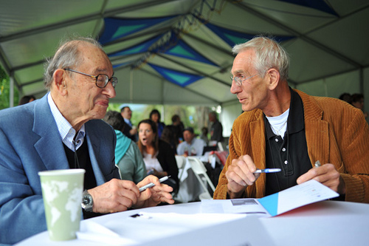

Talking with Alan Greenspan during the Aspen Ideas Festival 2009 (photo: The Aspen Institute).

